Oscar Medina
CS-340-16224-M01 Client/Server Development
Kim, Peter
May 27, 2026
CS 340 Project Two
Grazioso Salvare has requested documentation to accompany the code for your dashboard. This will ensure that they are able to understand the work that was completed and more easily maintain the code for this project.
You have been asked to create a README file that documents the project and includes instructions for reproducing the project. Be sure to address all the following areas:
- Describe the required functionality of the project. Include the screenshots or screencast taken while testing and deploying your dashboard (Step 6) as proof that you have achieved the required functionality.
The Project Two Dashboard implements a functional integrative dashboard for Grazioso Salvare using a previously created CRUD interface. Grazioso Salvare is a nonprofit organization that specializes in training rescue animals. Grazioso Salvare has a vast database of animals on their Austin Animal Center. This project allows their organization to better filter and query animals based on their training data. Authorized users can Query the AAC dataset stored on MongoDB. To better refine the search “filters” have been added. These are based on search types, defaulted to rescue , training age in weeks, neuter vs intact status, and last updated location of the animal.

Water Rescue-
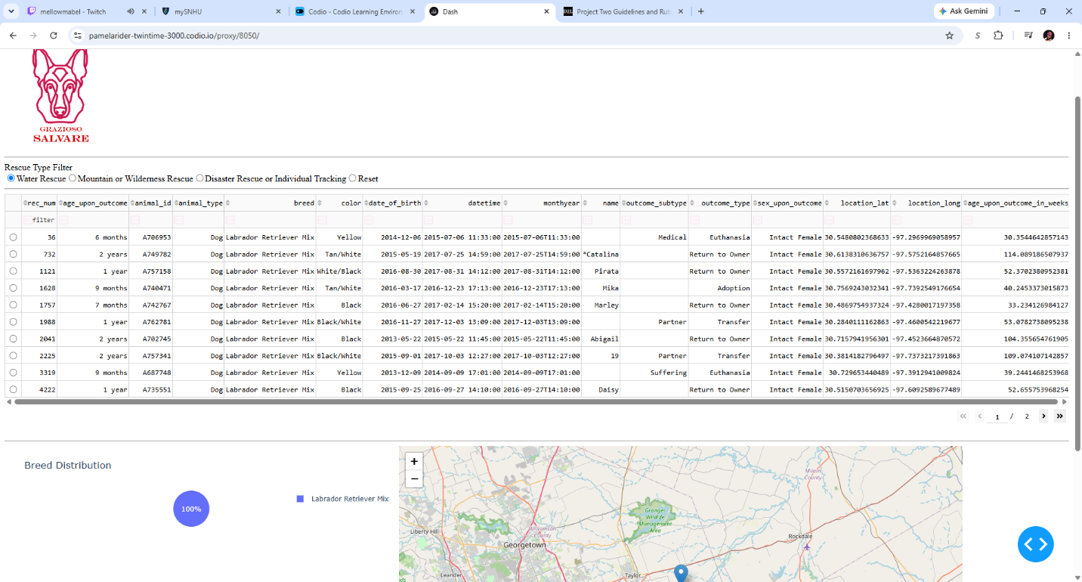
Mountain Rescue-
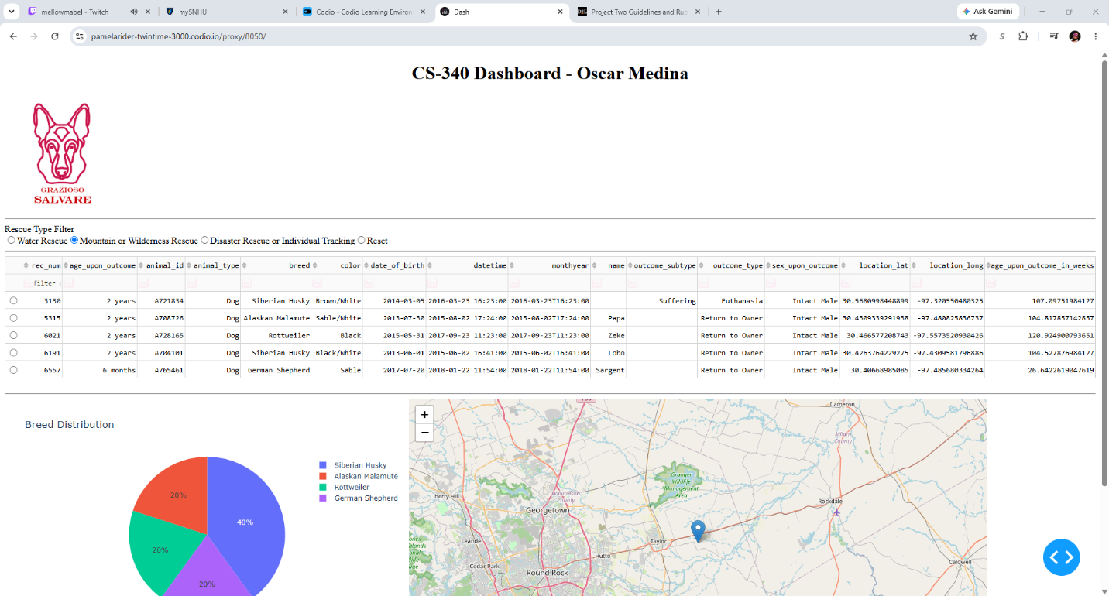
Disaster Rescue and Individual Tracking-
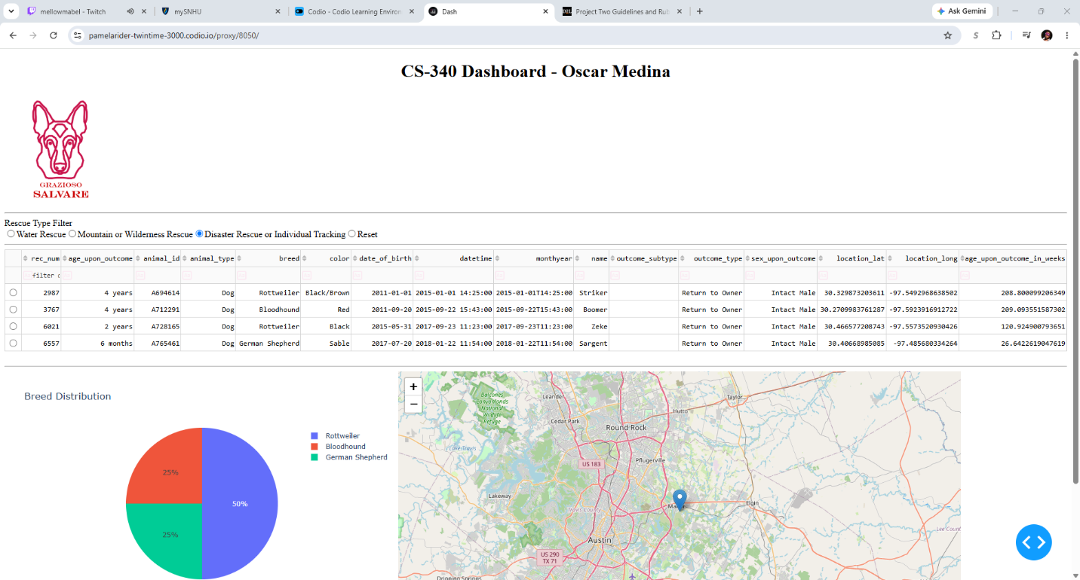
Even after using the filters a Reset option will return the dashboard to its initial unfiltered state.
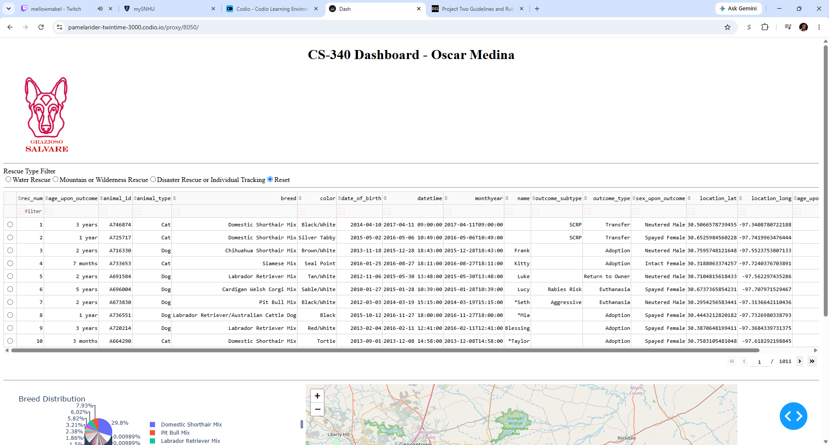

The Dashboard is fully interactive and even allows for manual Queries along with breakdowns on the results of such. The dashboard implements sorting, pagination, row selection, map visualization, and graph visualization.
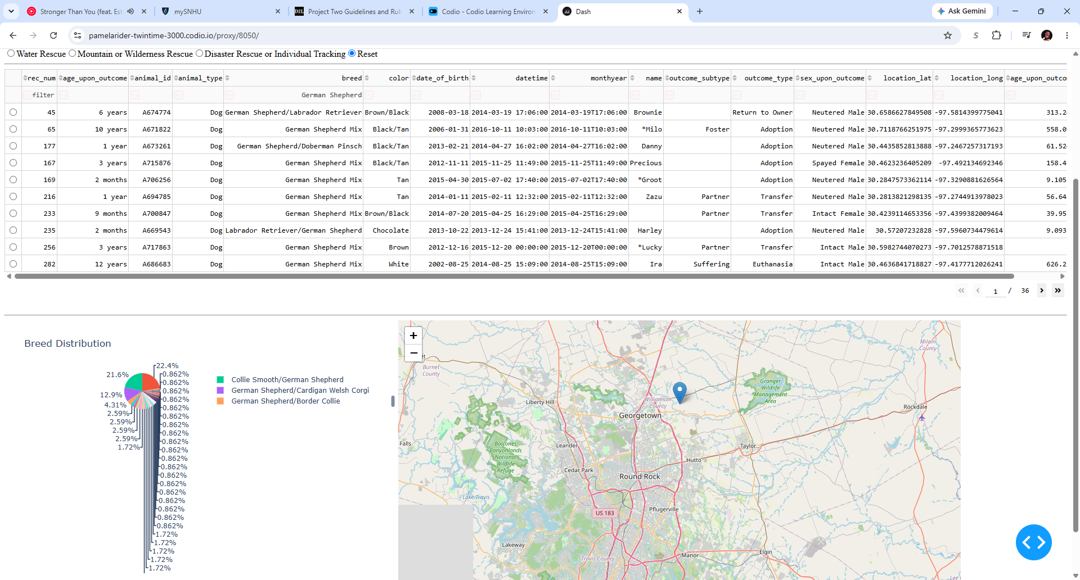

Tools and Resources used:
The tools used to bring this project to life are varied, but a breakdown is necessary to explain them well. First, MongoDB an open-source NoSQL database management system. It is a tool to store data in JSON-like documents for dynamic scalability and adaptable for restructuring (MongoDB), perfect to integrate into modern python and Pandas applications. The next tool is Dash Frameworks, they are an MVC-style web framework made in Python. It has a reactive UI using fast updates through callbacks. It has built-in components like graphs, maps, PNGs, charts and DataTables which are perfect for this project. More importantly it has built-in HTML so there is no need for extra extensions or tools like JavaScript (). Additionally, Dash has easy to implements controllers like “update_dashboard()”. Another important tool is Dash Leaflet; it is a tool to plot locations on maps using the latitude and longitude fields. JupyterDash is another important tool for local development to do inline testing and running the Dashboard inside the JupyterLab environment. Pymongo, a Python base drive to work with the MongoDB environment.
df = pd.DataFrame.from_records(db.read_all({}))
The steps to reproduce the Dashboard project:
First the dependencies must be installed, this can be mitigated if the environment is already preloaded, but they still need to be imported to initialize.
“pip install dash dash-leaflet pandas pymongo plotly jupyter_dash”
First MongoDB must be structured to store the datasets. The aac (Austin Animal Center) datasets must be imported into the MongoDB shell. A Python CRUD module must also be created to be compatible with the Dashboard application. An admin account must be set up to isolate the controls of the database. Once that is set the Dash must be able to access the database in MongoDB and the CRUD module. To do that the Username and password created for the dataset’s administrator must be coded. Once the controllers are properly set up then the app can be run. The Dashboard tool is very easy to create and use if the other two main components are running nicely.
“app.run_server()”
Once the app is running then the filter can be used. Adding new filters is not hard the longest either the filters and their radio buttons are coded correctly.
Challenges Encountered and Solutions:
The main issues I ran were Map callbacks and Indexing issues.
Map callbacks Index Errors are vast, but they mostly occurred because I was missing safeguards or elements when interesting with the Dashboard. A prominent one was my app crashing because elements were not reached. A solution was changing my map elements to “if not” loops to prevent crashes like “if not index: row = 0.” Another difficulty I ran into was Query errors. The most common was small MongoDB and other syntax errors. In an occasional my Query did not return result on the “water” filter query because my Regex Query was typed as “regex” rather than “$regex” on the “ “sex_upon_outcome”: {“$regex”: “Intact Male”, “$options”: “I”}” query. Similarly to prevent crashes results that have given empty queries must be dealt with. Finally, I just kept misspelling breed names which with the rigid Regex Query gave me empty results.
List of Technology and resources used:
Eriksen, E. (n.d.). Dash Leaflet. Dash Leaflet. https://www.dash-leaflet.com/
MongoDB. (n.d.). What is MongoDB? https://www.mongodb.com/company/what-is-mongodb
Plotly. (2026). DASH | the Open-Source Python framework for data applications. https://plotly.com/dash/
Jupyter. (2026). Project Jupyter. Home. Retrieved June 27, 2026, from https://jupyter.org/
Python. (2026, June 23). Welcome to Python.org. Python.org. https://www.python.org/

